SOFT8026 - Data-driven Microservices
Assignment 2 Form

Instructions
Please complete the following form and include in the zip file you submit. Include screenshots / images in the appendices below the form.

Move to Kubernetes
Describe the progress you made moving your app to Kubernetes | The process of moving over to Kubernetes was slightly difficult at first regarding tagging the containers I wanted to be stored by docker.  Once set up though I created files with all my deployments and an handy readme to refer back to for useful console commands, screenshots of it running in Kubectl below
Describe what additional functionality you added, e.g. 2nd data source; include decisions made around architecture to include the extra functionality. | I added a Digimon dataset as most of the data was like the Pokémon data. This meat originally that I wouldn’t have to change the analytics client however this changed as I couldn’t get the server the accept command line input to switch its datasets on start.  Instead I had two server containers and two analytic containers that sent their data to Redis. Minimal changes had to be made to the clients and servers, just changing the ports they used and renaming some of the fields.  I added a new section to the website using the new data. With Digimon data now available along with Pokémon data.
Describe your scaling and update strategy (as implemented in your Kubernetes deployments) – e.g. include why you chose to scale in the ratio among microservices that you did | I settled on 2 servers, 2 for Pokémon data and 2 for Digimon data. Then I had 1 analytics client for Pokémon and 1 for Digimon data. This then got stored on Redis which I found out can handle a lot more website clients than my PC could ever replicate.  This also allows for the data servers to be changed during a rolling update to introduce new data without stopping the new data.  Too many web containers slowed the entire system down due to a configuration error on my side not balancing containers between CPU cores properly etc.  While testing I had too many pods for my system to handle and 22gb of Ram was used by the docker Vmmem along with my 24 CPU threads being maxed out.

Testing
Briefly describe the test you created and what type of test it is? | I used K6 for testing as it allowed me to simply load test the website with users, I hit a limit within Linux and couldn’t scale past 4000 concurrent website users due to a limit on open files that was difficult to change.
Why did you choose that test? | It allowed me to simply load test the website, it was simple to setup and operate. The scripts is below along with the testing results
How did or how would you automate the test? | The tests runs itself once started and it can be configured for different run times. It could be setup to run for the day with simulated peaks and dips in users etc.  It’s started via command-line so a test can be easily automated. Another script can be setup just to immediately start with a number of numbers users and times etc so it can be easily started via command line.

Monitoring
Briefly describe the monitor you created and what type of monitor it is? | In order to monitor my Kubernetes, I used Splunk. I did try Kubernetes dashboard but setting it up was difficult and broke my connection to docker Kubernetes when I set up the proxy.
Why did you choose that monitor? | It installed very fast and immediately gave me a web dashboard where I could see all the details about my pods.
Serverless Function
What serverless function and functionality did you implement? | Kubeless is seemingly deprecated and the QuickStart guides are tutorials have been taken down.
Where in your application did you or would you slot in this functionality? | I intended to write a simple python program that would return if the server was working as intended or to automatically run a load test
Any other comments?  (e.g. you may have had to opt for Plan B, using Compose to implement extra functionality) | I tried to setup 3 different serverless systems, openfaas, fission and faas-netes, none of which worked.  Open Faas was more promising but required a login in that I couldn’t find

Appendix A – Screenshot(s) of your application running (e.g. Kubernetes log output, any web pages, etc.)
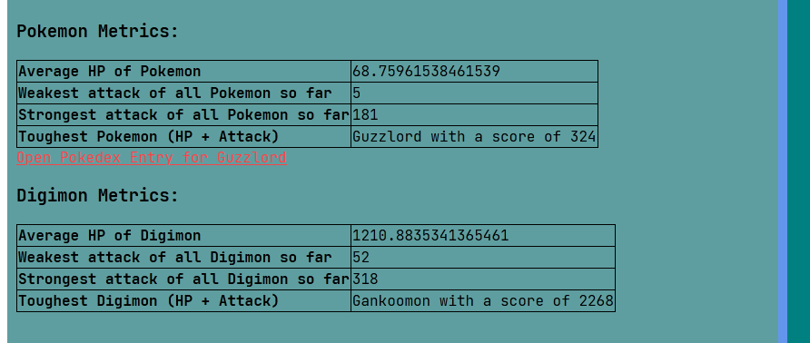
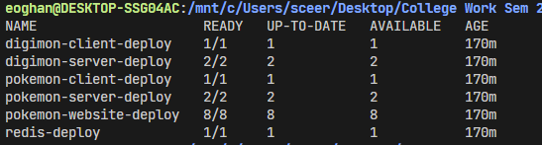

Appendix B – Screenshot(s) of your application being tested

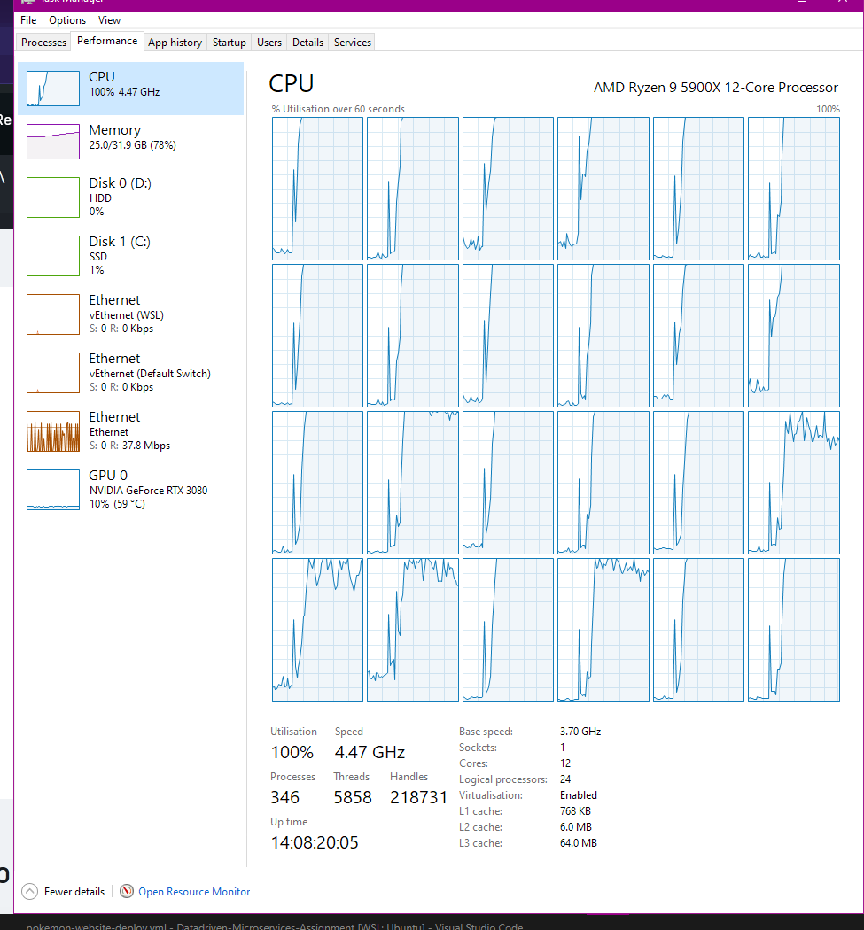
Figure 1 With 4 servers, 4 clients, 2 Redis and 16 webservers being used by 3500 simulated users. Computer was not too happy

Appendix C – Screenshot(s) of your application being monitored

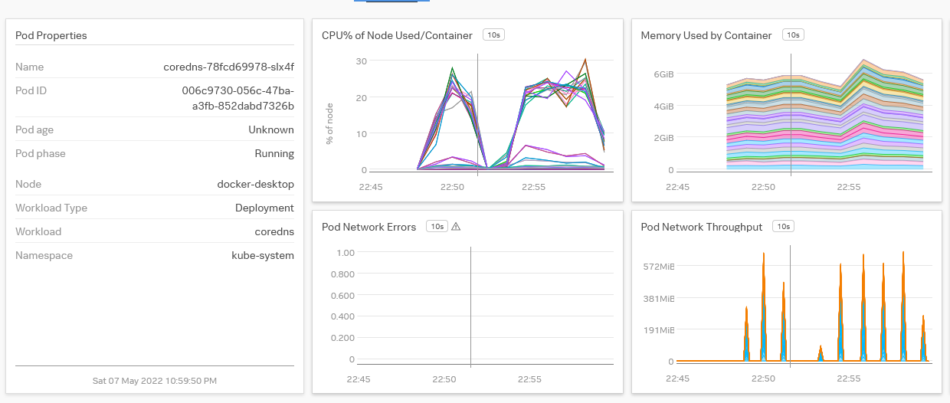
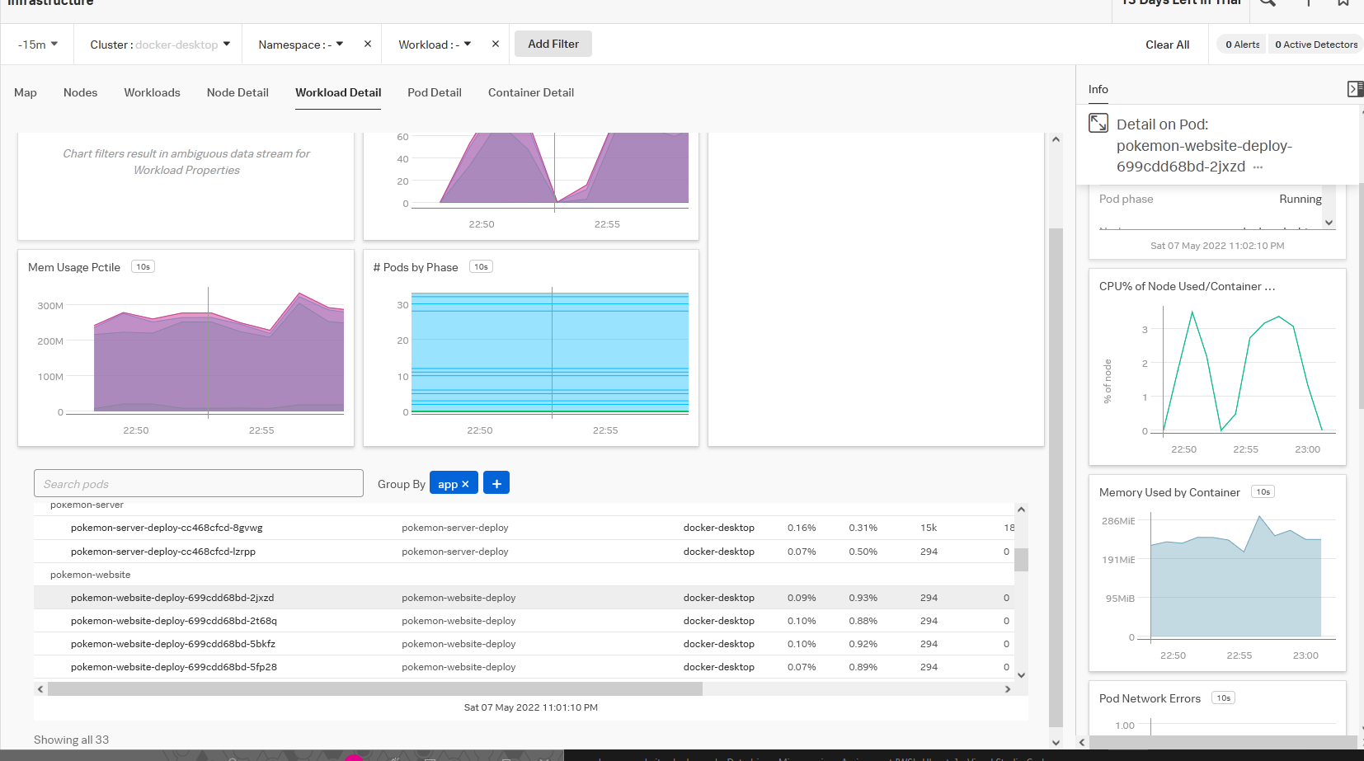

Appendix D – Screenshot(s) of your serverless function running
